Creating Cisco IOS Image Backup

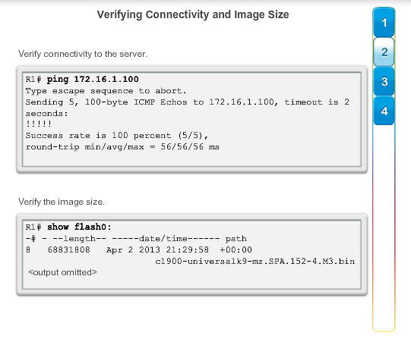

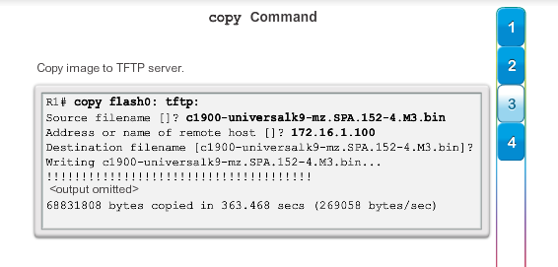

Copying a Cisco IOS Image Backup From TFTP Server Into Router

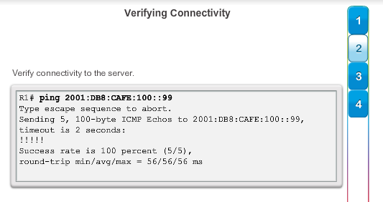

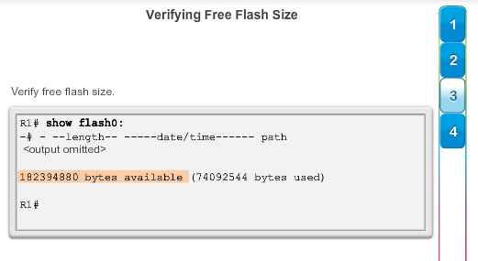

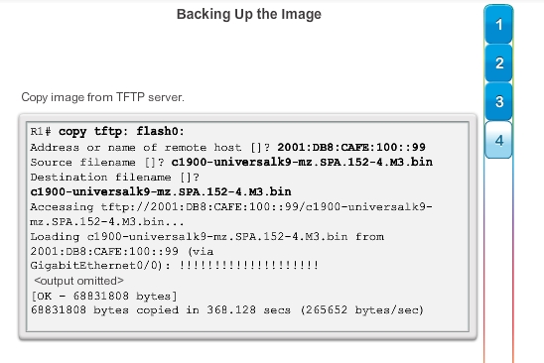

Boot System

-po tom, co si si zalohoval system na tftp server, si mozes router/switch nabootovat z apdejtovaneho obrazu disku z flash pamate

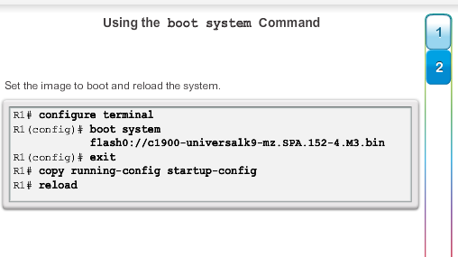

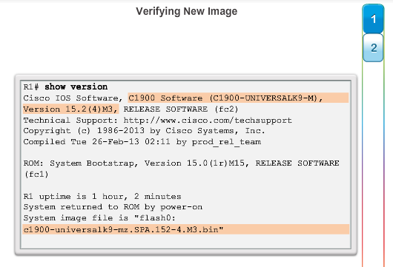

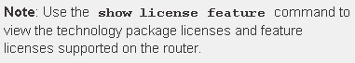

Instalacia licencie na odblokovanie sucasti IOSu (verzia 15+)

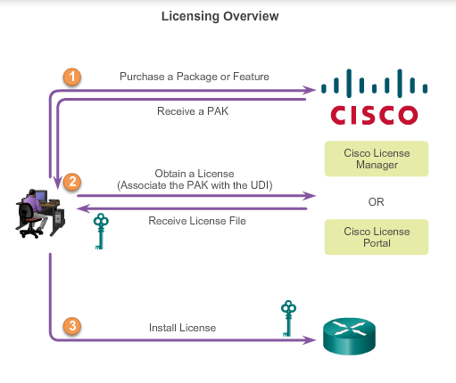

the **show version** command is used after the router is reloaded to verify that license has been installed.

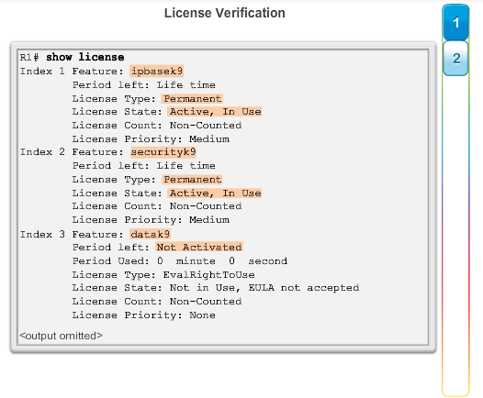The **show license** command is used to display additional information about Cisco IOS software licenses.

The **license accept end user agreement** global configuration mode command is used to configure a one-time acceptance of the EULA for all Cisco IOS software packages and features. After t

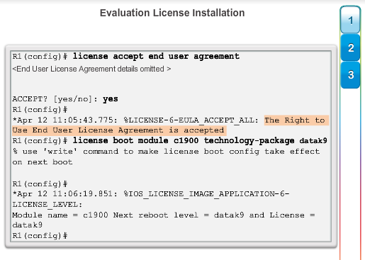

**Note**: A reload using the **reload** command is required to activate the software package.

License BackUp

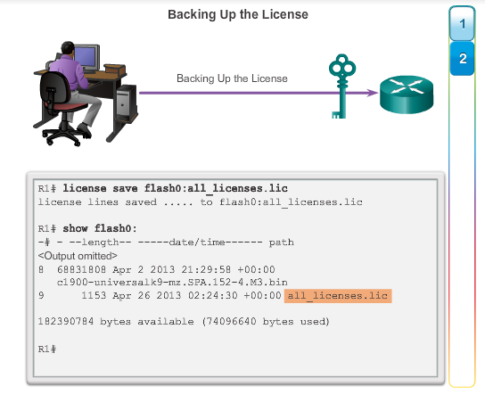

Uninstalling a License

